**Using Typescript in your project**

1. Open Visual studio code
2. Open the project folder via Terminal or command Prompt
3. Install Typescript - **npm install -g typescript**
4. Create a file called **app.ts**
5. Paste the below code.

*console.log("Hello world")*

*function welcomeuser(user:User):string*

*{*

*console.log(`Hey ${user.firstname} ${user.lastname} - Welcome to SPFx training`);*

*return `Hey ${user.firstname} ${user.lastname} - Welcome to SPFx training`*

*}*

*const username = {*

*firstname: "Jenkins",*

*lastname: "NS"*

*}*

*interface User{*

*firstname: string;*

*lastname: string;*

*}*

*welcomeuser(username)*

1. To execute compile the ts to js
   1. *tsc app.ts*
      1. it will create app.js compiled js file
   2. execute the application ***node app.js***

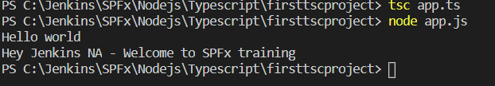

1. Create a configuration file
   1. tsc --init
   2. It will create the configuration file for typescript tsconfig.json
2. Then modify the es5 to es6 target ECMAScript

*"target": "es6"*

1. Then run ***tsc***
2. It will complile the ts file to js
3. And you can change the output folder
   1. *"outDir": "./dist",*
4. It will create a folder and create the js file under the folder.

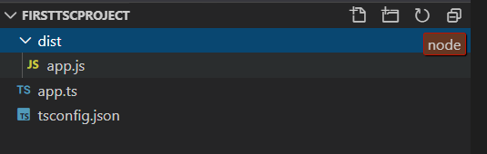

1. Move to dist folder and execute node app.js

